Event Sourcing is a design pattern where the state of an application is derived from a sequence of events, rather than directly persisting the state. Each event represents a change to the system, and the current state is reconstructed by replaying these events.

Key Components
- State
  - Represents the current snapshot of the application.
  - Derived from the sequence of past events.
  - Immutable in the context of the event store; only updated in memory by replaying events.
- Event
  - A fact that has occurred in the system.
  - Immutable and append-only.
  - Stored in an event log.
  - Examples:
    - OrderCreated
    - ItemAddedToCart
    - PaymentProcessed
- Event Store
  - The storage system that holds all events in chronological order.
  - Acts as the single source of truth.
  - Examples: Kafka, Event Store DB, or relational databases.
- Routing Rules
  - Define how events are routed to various components (e.g., read models, workflows, external systems).
  - Implemented using pub/sub mechanisms or event streams.
  - Examples:
    - Routing an OrderShipped event to the shipping service.
    - Sending an OrderCancelled event to a notification system.
- Workflow Specifications
  - Define the sequence of actions triggered by events.
  - Specify conditions and transitions for orchestrating complex processes.
  - Can be represented as state machines or orchestration logic.

High-Level Workflow
- Command Handling
  - A user or system issues a command (e.g., CreateOrder).
  - Commands are validated for business rules.
- Event Generation
  - Commands generate domain events upon successful execution.
  - Events are stored in the event store.
- State Reconstruction
  - The current state is rebuilt by replaying events.
- Routing and Propagation
  - Events are routed to subscribers for further processing.
  - Subscribers can be other services, workflow engines, or read-model builders.
- Workflow Execution
  - Events trigger workflows or state transitions as per specifications.
  - Workflows may emit additional commands or events.

Key Advantages
- Auditability
  - Every change is recorded as an event, ensuring a complete audit trail.
- Flexibility
  - Ability to rebuild state from scratch using event history.
  - Useful for debugging and implementing new business rules.
- Scalability
  - Events can be processed asynchronously and independently.
- Event-Driven Architectures
  - Enables integration with external systems and microservices.

Detailed Concepts

1. State
- Types of State:
  - Materialized State: The current state derived by replaying all or a subset of events.
  - Projection: A derived view of the state, optimized for querying (e.g., a summary of orders).
- Example:
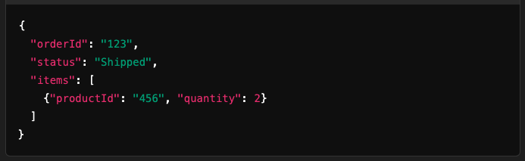

2. Event
- Structure of an Event:
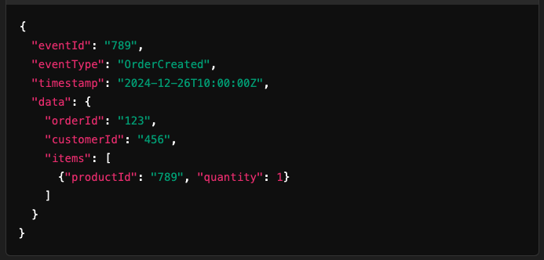
- Event Schema:
  - Event Type: Defines the kind of event (OrderCreated, OrderUpdated).
  - Event Data: The payload (specific to the event type).
  - Metadata: Additional information (e.g., timestamp, version).

3. Routing Rules
- Role:
Determine which components should handle specific events.
- Implementation:
  - Pub/Sub Mechanism:
    - Topics or event streams for decoupled communication.
    - Example: Kafka topics.
  - Rules:
    - Based on event types, metadata, or payload.
- Example Rule:
  - Route all PaymentProcessed events to the notification service.

4. Workflow Specifications
Workflows define the orchestration of tasks or events.
- Structure:
  - Trigger Event: An event that starts the workflow.
  - Conditions: Rules for branching or decision-making.
  - Transitions: Moving between states or triggering commands/events.
  - End State: Completion of the workflow.
- Example:
  - Trigger: OrderPlaced event.
  - Conditions:
    - Payment confirmed -> Move to OrderConfirmed.
    - Payment failed -> Emit OrderCancelled.
  - Transition:
    - Emit OrderShipped after confirming payment.
- Workflow Model:
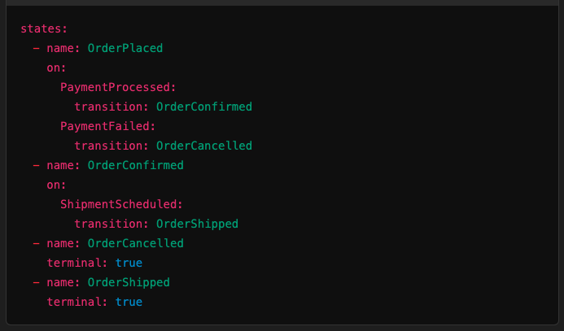

High-Level Example

Scenario: E-commerce Order Processing
- Command: CreateOrder
  - User places an order.
- Event: OrderCreated
  - Generated after validating and processing the command.
  - Stored in the event store.
- State Update:
  - Reconstruct the order state: OrderCreated -> PendingPayment.
- Routing:
  - Route OrderCreated to payment service.
- Workflow Execution:
  - Payment service processes the payment and emits PaymentProcessed.
- State Transition:
  - Workflow moves to the OrderConfirmed state and emits OrderShipped.

Implementation Tips
- Event Store:
  - Use a robust, distributed storage system like Kafka, Event Store, or DynamoDB.
- Event Versioning:
  - Design events with versioning in mind to handle schema changes.
- Workflow Engine:
  - Use workflow orchestration tools like Temporal, Zeebe, or a state machine library.
- Projections:
  - Create optimized read models for queries using tools like Elasticsearch or dedicated databases.

